Erika Michelle Zayas San Antonio May 27, 2011.
CCOM 4086 – Computer Architecture S.N: #801-07-9760
Prof. Humberto Ortiz Zuazaga

Decoder

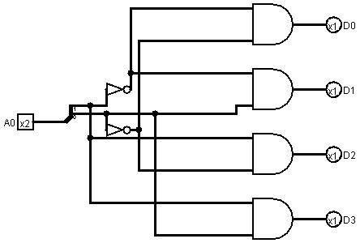

A decoder is a combinational circuit that converts binary information from n inputs to exactly one output of a maximum of 2^{n} outputs. A 2-to-4 decoder operates according to the following truth table:
A₀ |  | D₀ | D₁ | D₂ | D₃
0 | 0 | 1 | 0 | 0 | 0
0 | 1 | 0 | 1 | 0 | 0
1 | 0 | 0 | 0 | 1 | 0
1 | 1 | 0 | 0 | 0 | 1

D₀ = A₀’ A₀’
D₁ = A₀’ A₀
D₂ = A₀ A₀’
D₃ = A₀ A₀
The 2 bit input is called A₀ and the four outputs are called D_{0,} D_{1,} D_{2,} D_{3.} The output D₀ is true only when the input A₀ = 00, the output D₁ is true only when the input A₀ = 01, the output D₂ is true only when the input A₀ = 10, and the output D₂ is true only when A₀ = 11. This is that for every input it will be a uniquely output. Every instruction has a field known as operation code which indicates the type of operation to be realized. The decoder is the one in charge to extract the operation code in course, analyze it and emit signals to the rest of the elements. In our design, the decoder is the responsible to indicate in which of the registers the process will be written.

